Security Operations Center (SOC) : Monitoring, Analysis, and Incident Handling
Harsh Vasoya
CyArt
16/01/2026
Internship Week 3 Documentation

1. Overview

This report presents the practical SOC activities carried out during Week 2 of the internship program. The primary objective of this week was to understand and apply real-world SOC workflows, starting from event detection and analysis to escalation, forensic handling, and reporting. The tasks were performed in a controlled virtual lab environment consisting of a SOC Manager system and an endpoint monitored through a SIEM solution. The exercises emphasized operational accuracy, structured analysis, and professional documentation.

2. Task 1: Advanced Log Monitoring and Event Correlation

The first task focused on monitoring and analyzing system logs to identify suspicious activity through correlation rather than isolated events. On the endpoint system (VM2), repeated Secure Shell (SSH) authentication failures were generated. These failed login attempts were recorded in the Linux authentication log file (/var/log/auth.log). The monitoring agent installed on the endpoint continuously collected these logs and forwarded them to the SOC Manager system.

On the SOC Manager (VM1), the SIEM dashboard was used to analyze the collected logs. By applying filters such as agent name, time range, and SSH-related keywords, multiple authentication failure events were observed occurring within a short time interval. This repetitive pattern deviated from normal user behavior and indicated a potential brute-force login attempt. Correlating multiple events allowed the suspicious activity to be identified more effectively than analyzing a single alert.

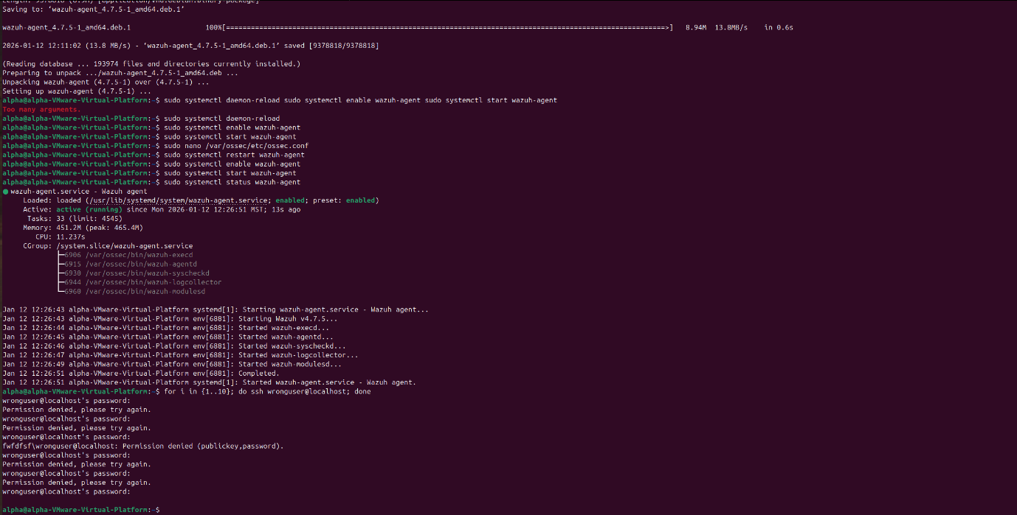

Terminal output on VM2 showing repeated SSH login attempts

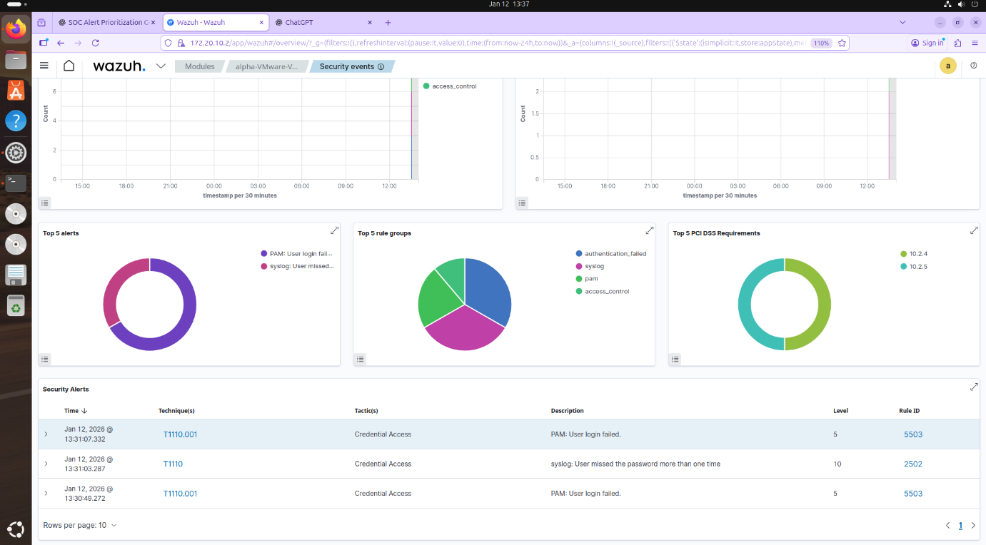

SIEM “Security Events” view on VM1 displaying multiple SSH authentication failure logs

3. Task 2: Threat Intelligence Validation and Alert Enrichment

The second task involved enriching the detected alert with external threat intelligence to better understand its context. The source IP address associated with the SSH authentication failures was extracted from the SIEM alert. This indicator was then validated using publicly available threat intelligence platforms.

The IP address was first analyzed using VirusTotal to check its reputation across multiple security engines and intelligence sources. Subsequently, AlienVault OTX was used to determine whether the indicator appeared in any known threat pulses. The analysis revealed that the IP address belonged to an internal/private range and was not associated with known malicious activity. Although the indicator was not flagged as malicious, this task demonstrated the correct investigative workflow for validating Indicators of Compromise (IOCs) and reducing false positives.

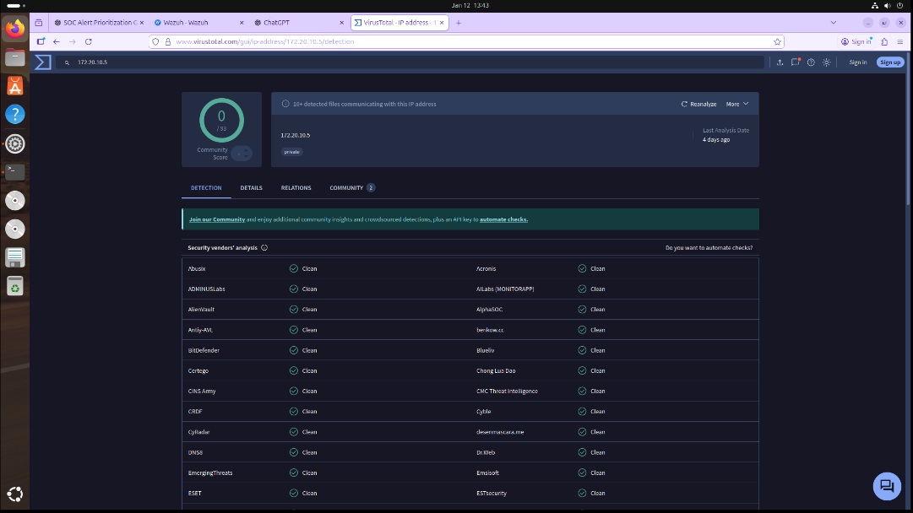

VirusTotal search results for the source IP address

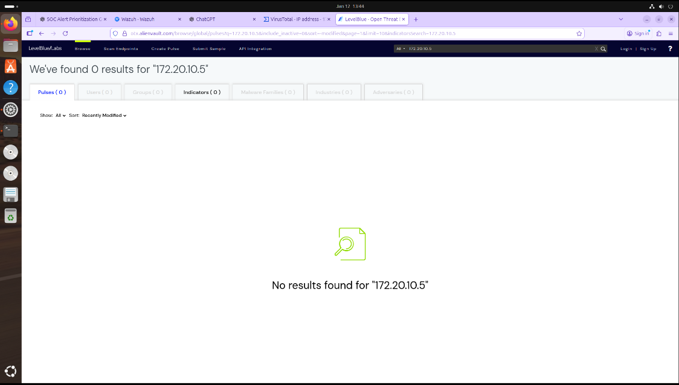

AlienVault OTX search results showing pulse information or absence of malicious classification

4. Task 3: Alert Triage and Severity Assessment

In this task, alert triage was performed to determine the validity and priority of the detected security event. The SIEM alert details were examined carefully, including rule description, severity level, timestamps, source IP address, affected asset, and associated attack technique. Special attention was given to the frequency and timing of the authentication failures.

The repeated nature of the SSH login failures within a short time window confirmed that the alert represented suspicious activity rather than a user error. Based on this assessment, the alert was classified as a true positive with a medium severity rating. The triage outcome was documented in a structured table, capturing all relevant information and the analyst’s final decision. This step demonstrated how SOC analysts prioritize alerts and decide which incidents require further action.

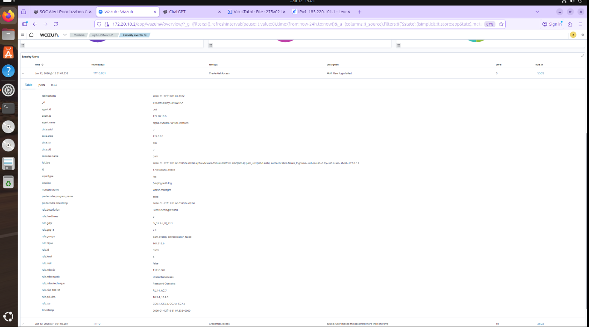

SIEM alert “Document Details” view showing rule ID, severity, and alert metadata

Field | Details
Alert ID | ALRT-SSH-002
Alert Name | SSH Brute-Force Authentication Failure
Detection Tool | Wazuh SIEM
Detection Date | 15-01-2026
Detection Time | 19:45 IST
Affected Asset | Ubuntu Endpoint (VM2)
Agent Name | VM2-Agent
Agent IP | 172.20.10.5
Source IP Address | 127.0.0.1
Target Service | SSH
Rule ID | 2502
Rule Level | Medium
MITRE ATT&CK Technique | T1110 – Brute Force
Alert Frequency | Multiple failed login attempts in short time interval
Threat Intelligence Sources Used | VirusTotal, AlienVault OTX
Threat Intelligence Result | No known malicious reputation (internal IP)
Analyst Analysis | Repeated authentication failures indicate suspicious behavior
Triage Classification | True Positive
Incident Severity | Medium
Recommended Action | Escalate to Tier-2 SOC for further investigation
Alert Status | Escalated

Alert triage documentation table created in the report or Google Docs

5. Task 4: Incident Escalation and Communication

Following the triage process, the incident was escalated from Tier-1 SOC to Tier-2 SOC for further investigation. The decision to escalate was based on the persistence of the suspicious activity and the potential risk of credential compromise. A structured escalation summary, also known as a Situation Report (SITREP), was prepared to ensure clear communication between SOC tiers.

The escalation summary included the incident title, detection time, affected system, source IP address, associated attack technique, actions taken by Tier-1 analysts, and the reason for escalation. This documentation ensured that Tier-2 analysts could quickly understand the incident context without repeating initial analysis. The task highlighted the importance of clear and concise communication during incident response operations.

Escalation Summary – SOC Tier Handover

Incident Title: SSH Brute-Force Authentication Attempts
Incident ID: INC-SSH-002
Detection Tool: Wazuh SIEM
Detection Date: 15-01-2026
Detection Time: 19:45 IST

Affected Asset: Ubuntu Linux Endpoint (VM2)
Source IP Address: 127.0.0.1
Target Service: SSH
MITRE ATT&CK Technique: T1110 – Brute Force

Incident Summary:

Multiple failed SSH authentication attempts were detected on the Ubuntu endpoint within a short time interval. Log analysis confirmed repeated login failures originating from the same source IP. Alert triage classified the event as a true positive with medium severity. Threat intelligence validation using VirusTotal and AlienVault OTX did not identify a known malicious reputation for the source IP, indicating potential internal testing or misconfiguration.

Actions Taken by Tier-1 SOC:
- Analyzed and correlated SSH authentication logs
- Performed alert triage and severity assessment
- Validated indicators using threat intelligence platforms
- Preserved authentication log evidence and documented findings

Reason for Escalation:

The persistent nature of the authentication failures requires further investigation to determine potential credential misuse or system configuration issues.

Current Status:

Escalated to Tier-2 SOC for further analysis.

6. Task 5: Evidence Preservation and Chain of Custody

This task focused on preserving digital evidence in accordance with basic forensic principles. The authentication log file containing the SSH login failures was identified as critical evidence. The existence of the file was verified, and a cryptographic hash was generated using the SHA-256 algorithm to ensure data integrity.

A forensic copy of the log file was created and stored in a secure directory with read-only permissions to prevent modification. All evidence handling steps were documented, including file paths, hash values, collection timestamps, and analyst details. Additionally, a chain of custody record was maintained to track every action performed on the evidence. This process ensured traceability, accountability, and compliance with forensic best practices.

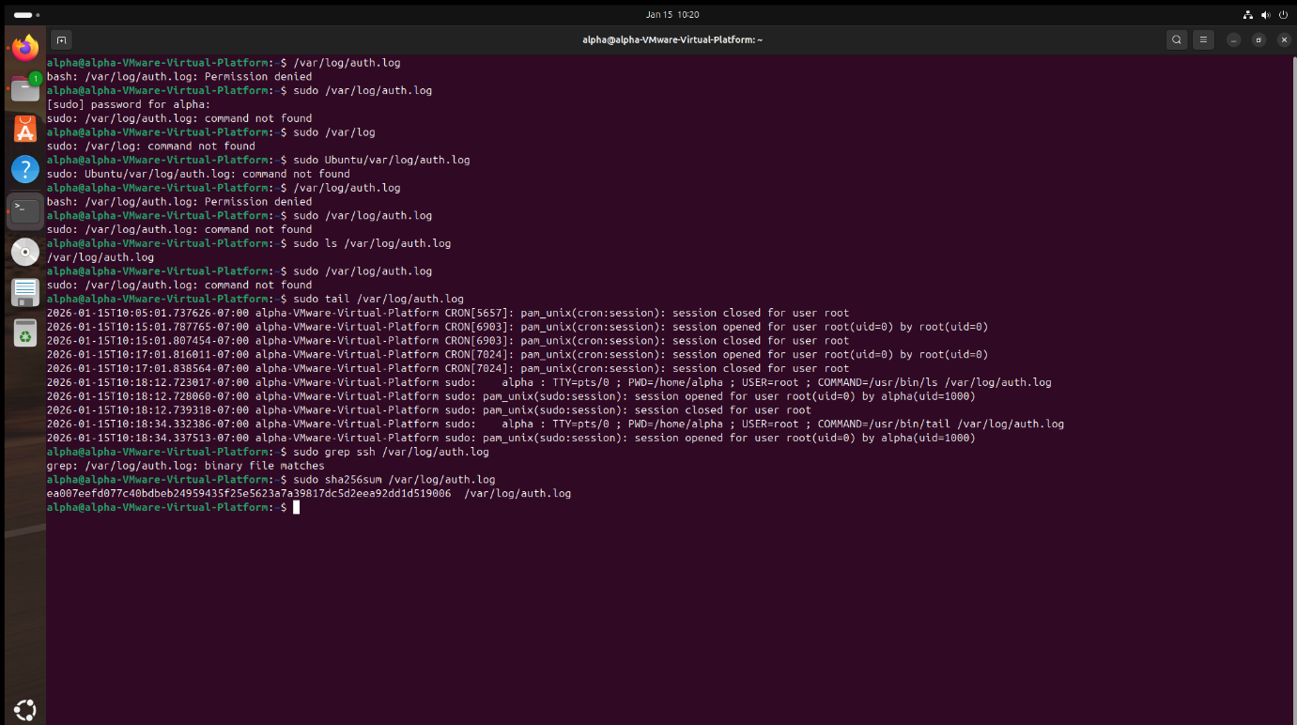

Terminal output showing SHA-256 hash generation of the evidence file

Terminal output showing the read-only permissions of the evidence copy
Date | Time (IST) | Action Performed | Evidence Item | Location | Responsible Person
15-01-2026 | 20:10 | Identified authentication log as relevant evidence | /var/log/auth.log | VM2 (Endpoint) | SOC Analyst
15-01-2026 | 20:12 | Verified existence and accessibility of evidence file | /var/log/auth.log | VM2 (Endpoint) | SOC Analyst
15-01-2026 | 20:15 | Generated SHA-256 hash to preserve evidence integrity | /var/log/auth.log | VM2 (Endpoint) | SOC Analyst
15-01-2026 | 20:18 | Created read-only forensic copy of evidence | auth.log.evidence | /home/alpha/ | SOC Analyst
15-01-2026 | 20:22 | Documented evidence details and custody information | auth.log.evidence | Report Document | SOC Analyst

Chain of custody table included in the report

7. Task 6: Capstone – Complete SOC Incident Handling Workflow

The final task integrated all previous activities into a complete SOC incident handling workflow. Suspicious activity was generated on the endpoint system, detected by the SIEM, analyzed through log correlation, enriched with threat intelligence, triaged, escalated, and documented. Evidence was preserved following forensic standards, and a structured incident report was prepared summarizing the entire investigation.

In addition to technical documentation, a management-level briefing was created to communicate the incident details and response actions in non-technical language. This ensured that stakeholders without technical backgrounds could understand the situation and decisions made. The capstone task demonstrated the ability to handle a security incident from detection to final reporting, reflecting real-world SOC operations.

8. Conclusion

The Week 2 practical activities provided extensive hands-on experience with core SOC processes. Through log analysis, threat intelligence validation, alert triage, escalation workflows, evidence preservation, and comprehensive reporting, the tasks simulated real-world incident response scenarios. These exercises improved analytical skills, reinforced the importance of structured workflows, and emphasized accurate documentation and communication. Overall, the assignment significantly enhanced practical readiness for operational roles within a professional Security Operations Center.

